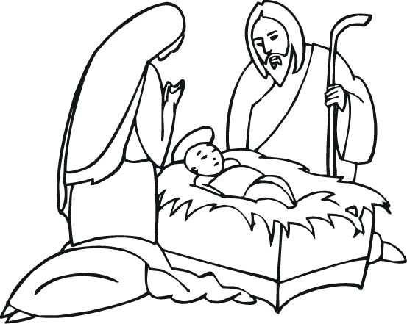
CHRISTMAS COLORING CONTEST!

Name: _______________________

Color this picture and bring it with you tomorrow.
We will pick winners from each bus route!

Be ready for the bus around: _________

FELLOWSHIP
BAPTIST CHURCH
For more info • 624-8939
CHRISTMAS COLORING CONTEST!

Name: _______________________

Color this picture and bring it with you tomorrow.
We will pick winners from each bus route!

Be ready for the bus around: _________

FELLOWSHIP
BAPTIST CHURCH
For more info • 624-8939

